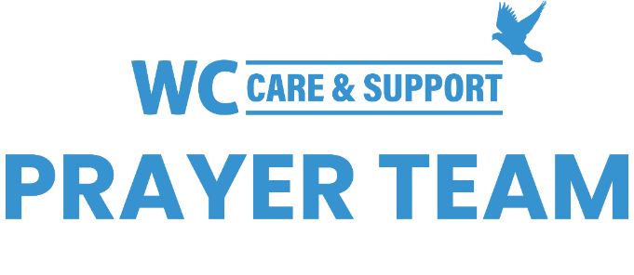
You may submit prayer requests at the following link or use this QR code: www.whiteschapel.org/prayers.html. Names will remain on this prayer list for two weeks, three weeks for deaths, unless otherwise notified. | 

Public Prayer List 04-27-2026

Dave Aistrup, Malta Akins, Cristina Almeida, Coleman Anderson, Andrew Armbrust, Chase Attwood, Karla Barker, David Baxley, Brent Bedgood, Julie Bessire, Nancy Bradley, Cyndy Brehmer, Bobbie Cameron, Josh Clark, Carolyn Cockerell, Inés Collazo, Bill and Jimmie Nell Cook, Charlotte Corbin, Leslie Craig, Bart Davis, Chris Deever, Trish Dethlefs, The Dicken Family, Robert Dixon, Tommy Duer, Jeanne Dusel-Fyfe, Linda Evans, Ralph Evans, Steve Ferney, Carol Fortune, Morris Gates, Shelly Gillette, Alice Knowles-Holliday, Robert Holmes, Bill Hood, Judy and Mike Howell, Claudia Jenkins, Tom Jenkins, CJ Jones, Jerry Kight, Matt Lafavers, Wayne Lee, Tim Little, Marsha Lloyd, Gary Long, Robin Long, Michael Lucas, Marshall Ludwig, Jerry and Linda Lukas, Liza and Ruel Lunar, Steven Mart, Sharon Martin, Katherine McCarthy, Elena McCreight, Trish McDaniel, Sue McNutt, Carson Miller, Jamaica Monticello, Lori Moravec, Jeri Morris, Christopher Owen, Connie Parra, George Pepper, Judy and Joe Petrazio, Azor Phelps Sr., Kay Pierce, Doris Pope, Bill Preston, Hall Purdeville, Norma Resendiz, Eddie Robertson, Bisquit Sadler, The Salvation Army Women’s Auxiliary, Barbara Shaw, Gregg Short, Doris Splichal, LeGrand Spradley, Brian Steidinger, Tom Sterrett, Luke Strain, Steve Swanston, Deanna Talbott, Paul Tanner, Randy Thomas, U.S. Military, Rick Warner, Joe Watford, Shannon Weimers, Leslie Williams, Luke Williamson, Carroll Willis, Vicki Winn, Melinda Witt, Ken Woodward, Kasey Young. Recent Deaths: The Family of Roland Anderson, The Apel Family, The Family of Ed Asten, The Family of Laszlo Bartha, The Family of Kenneth L. Harder, The Family of Sherwood Hensley, The Family of Jay Loucks, The Family of Reba Madera, The Family of Tessa McCall, The Family of Marcia Mills, The Family of Geri Mundhenk, The Family of Kenneth Preston, The Family of Robert Radtke, The Family of Gail Richardson, The Family of Kathleen Rushing, The Family of Scott Sabre, The Family of Ryan Seltzer, The Family of Lisa Smith, The Family of Buster Thrasher, The Family of Steven Van Wie, The Family of John Wermuth, The Family of June Yenco.

