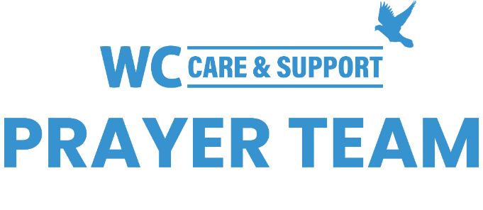
You may submit prayer requests at the following link or use this QR code: www.whiteschapel.org/prayers.html. Names will remain on this prayer list for two weeks, three weeks for deaths, unless otherwise notified. | 

Public Prayer List 02-09-2026

Malta Akins, Roland Anderson, Eric Ballweg, Meagan Lee Bauer, Matthew Bennett, Paula Benson, Jim Blair, Sue Bossow, Nancy Bradley, Tony Chapman, Kay Chapman-Coy, Carolyn Cockerell, Jennifer Conroy, Kelly Cook, Bill and Jimmie Nell Cook, Leslie Craig, James Davis, Carol Dominiec, Blake Ekborg, Ralph Evans, Kyle Fairchild, Brody Fisher, Jennette Forrester, Bobby Francis, David and Connie Fred, Morris Gates, Shelly Gillette, Susan Gilliam, Nancy Guthrie, Dee Hagmeier, Edie Harris, Joan Harrison, Joy Holekamp, Alice Knowles-Holliday, Robert Holmes, Mary Howry, Rob Johnson, The JD Johnston Family, Jerry Kight, Leslie King, Connie Lamb, Perry Lindsay, Jerry Lovelace, Leigh Lynde, John Major, Mari McAdoo, Tex McCarthy, Sue McNutt, Matthew Mitchell, Sherry Modeer, Dave Mueller, Marjean Nelson, Don Netzer, Alex Nuese, Katie Park, Avia Rose Patterson, Michael Paulk, Ray Payne, Bobby Phipps, Bill Preston, Brent Ratliff, Ginger Reynolds, Eddie Robertson, Jane Robertson, John Rosenburg, Samuel Schumacher, Shirley Scott, The Sheets Family, Paul Sikes, Del Spann, LeGrand Spradley, Julie Stapleton, Kim Stinson, Vera Strickland, Claire Summey, Steve Swanston, Celestine Tshimanga, Scott and Anna Vickers, Sharla Wendt, Thomas White, Carroll Willis, Kimberly Windsor, Vicki Winn, Melinda Witt, Lazette Woods, Helen Zapp, Kelly, Tapiwa. Recent deaths: The Cannon Family, The Family of Dave Carpenter, The Family of Ruth Cochran, The Family of Frank Forcelli, The Family of Don Gardner, The Family of Elizabeth "Tinkie" George, The Family of Colby Horn, The Family of Gloria Joseph, The Family of Duane McGuire, The Family of Steve Orr, The Family of Patsy Smith, The Family of Roger Trevino, The Family of Viola Winfrey, The Family of Mark Wolfe, The Family of Jim Woodard.

