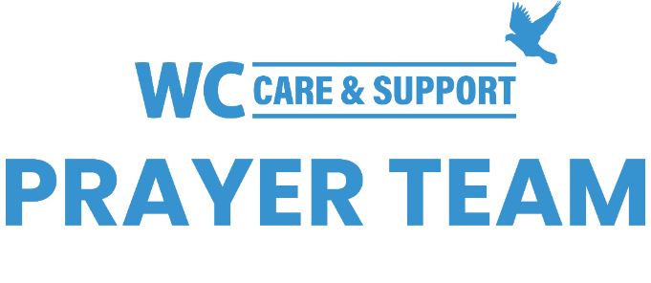
You may submit prayer requests at the following link or use this QR code: www.whiteschapel.org/prayers.html. Names will remain on this prayer list for two weeks, three weeks for deaths, unless otherwise notified. | 

Public Prayer List 02-16-2026

Malta Akins, Roland Anderson, Eric Ballweg, Paula Benson, Jim Blair, Nancy Bradley, The Butts Family, Tony Chapman, Kay Chapman-Coy, Carolyn Cockerell, Jennifer Conroy, Kelly Cook, Bill and Jimmie Nell Cook, Leslie Craig, Nevin Cunningham, Carol Dominiec, Blake Ekborg, Anna Ericson, Ralph Evans, Kyle Fairchild, Rose Fife, Brody Fisher, Jennette Forrester, Bobby Francis, David and Connie Fred, Morris Gates, Samantha Gaylor, Shelly Gillette, Susan Gilliam, Nancy Guthrie, Amy Guzzy and Family, Dee Hagmeier, Edie Harris, Joan Harrison, Elaine and Jared Hazleton, Alice Knowles-Holliday, Robert Holmes, Ron Holmes, Duke Howard, Mary Howry, Rob Johnson, Jerry Kight, Connie Lamb, Joshua Librera, Perry Lindsay, Jerry Lovelace, Mari McAdoo, Tex McCarthy, Sue McNutt, Sherry Modeer, Dave Mueller, Don O'Brien, Christopher Owen, Katie Park, Billy Parker, Avia Rose Patterson, Michael Paulk, Ray Payne, Amy Perry, Azor Phelps Sr., Helen Post, Bill Preston, Brent Ratliff, Ginger Reynolds, Eddie Robertson, John Rosenburg, Shirley Scott, The Sheets Family, Paul Sikes, LeGrand Spradley, Julie Stapleton, Kim Stinson, Vera Strickland, Steve Swanston, Karoline E.Z. Thomas, Kaelib J.T. Thomas, Rhoda Truitt, Rick Warner, Jackie Wasson, Sharla Wendt, Thomas White, Carroll Willis, Kimberly Windsor, Vicki Winn, Melinda Witt, Helen Zapp, Kelly, Tapiwa. Recent deaths: The Family of Matthew Bennett, Brooke and Terrell Everts and Family, The Cannon Family, The Family of Dave Carpenter, The Family of Ken Cornell, The Roy Folse Family, The Family of Frank Forcelli, The Family of Don Gardner, The Family of Elizabeth "Tinkie" George, The Family of Colby Horn, The Family of Gloria Joseph, The Family of Duane McGuire, The Family of Don Netzer, The Family of Steve Orr, The Family of Bobby Phipps, The Family of Jane Robertson, The Family of Patsy Smith, The Family of Kasey Mae Thomas, The Family of Viola Winfrey, The Family of Jim Woodard.

