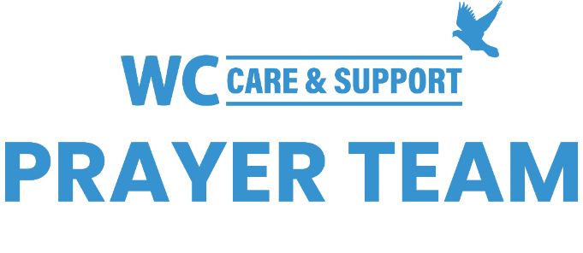
You may submit prayer requests at the following link or use this QR code: www.whiteschapel.org/prayers.html. Names will remain on this prayer list for two weeks, three weeks for deaths, unless otherwise notified. | 

Public Prayer List 02-23-2026

Malta Akins, Roland Anderson, The Andrew Blackwell Family, Jim Blair, Nancy Bradley, The Butts Family, Kay Chapman-Coy, Carolyn Cockerell, Bill and Jimmie Nell Cook, Billy Ray Courtney, Leslie Craig, Nevin Cunningham, Gerald Daniel, Joan Daniel, Martin Dunbar, Blake Ekborg, Anna Ericson, Ralph Evans, Kyle Fairchild, Rose Fife, Brody Fisher, Jennette Forrester, David and Connie Fred, Morris Gates, Dexter Gatlin, Samantha Gaylor, Shelly Gillette, Susan Gilliam, Marine Military Academy, Harlingen TX and Families, Amy Guzzy and Family, Dee Hagmeier, Edie Harris, Joan Harrison, Elaine and Jared Hazleton, Keira Hodges, Robert Holmes, Ron Holmes, Trey Holston, Duke Howard, Mary Howry, Michelle James, Rob Johnson, Jerry Kight, Connie Lamb, Joshua Librera, Jerry Lovelace, Reece Marshall, Mari McAdoo, Tex McCarthy, Sue McNutt, Lisa Moore, Tanner Mosey, Dave Mueller, Chuck Neuman, Don O'Brien, Christopher Owen, Billy Parker, Betty Paul, Michael Paulk, Ray Payne, Amy Perry, Azor Phelps Sr., Rhonda Pickrell, Kay Pierce, Matthew Pollman, Helen Post, Bill Preston, Brent Ratliff, Bobby Rawls, Ginger Reynolds, Eddie Robertson, Jean Elias Samaan, Shirley Scott, Kathy Seoane, Paul Sikes, LeGrand Spradley, Julie Stapleton, Kathie Streeter, Maureen Sullivan, Steve Swanston, Oscar Temblador, Kaelib J.T. Thomas, Karoline E.Z. Thomas, Rhoda Truitt, Rick Warner, Jackie Wasson, Megan and Eric Whitehead, Carroll Willis, Linda Winant, Vicki Winn, Melinda Witt. Recent deaths: The Family of Matthew Bennett, Brooke and Terrell Everts and Family, The Cannon Family, The Family of Dave Carpenter, The Family of Ken Cornell, The Family of Blake Dorman, The Roy Folse Family, The Family of Elizabeth "Tinkie" George, The Family of Colby Horn, The Family of Gloria Joseph, The Family of Stacy Kissinger, The Family of Duane McGuire, The Family of Rebecca Moore, The Family of Paolo Natale, The Family of Don Netzer, The Family of Courtney Smallidge Nymeyer, The Family of Bobby Phipps, The Family of Jane Robertson, The Family of Jack Schrenkenhofen, The Family of Kasey Mae Thomas, The Family of Viola Winfrey, The Family of Jim Woodard.

