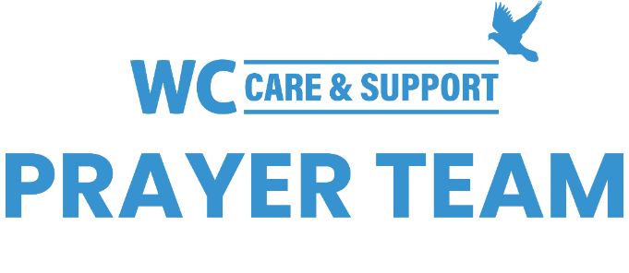
You may submit prayer requests at the following link or use this QR code: www.whiteschapel.org/prayers.html. Names will remain on this prayer list for two weeks, three weeks for deaths, unless otherwise notified. | 

Public Prayer List 03-02-2026

Malta Akins, Roland Anderson, Brent Bedgood, The Andrew Blackwell Family, Jim Blair, Nancy Bradley, Zach Bruton, Kay Chapman-Coy, Carolyn Cockerell, Bill and Jimmie Nell Cook, Billy Ray Courtney , Leslie Craig, Nevin Cunningham, Gerald Daniel, Joan Daniel, Amy DeGray, Paige Dobyns, Martin Dunbar, Sue Ensslen and Family, Anna Ericson, Ralph Evans, Kyle Fairchild, Kyle Fairchild, Rose Fife, Jennette Forrester, David and Connie Fred, Morris Gates, Dexter Gatlin, Samantha Gaylor, Shelly Gillette, Susan Gilliam, Marine Military Academy, Harlingen TX and Families, Amy Guzzy and Family, Dee Hagmeier, Joan Harrison, Andreas Hartmann, Elaine and Jared Hazleton, Keira Hodges, Joy Holekamp, Alice Knowles-Holliday, Robert Holmes, Ron Holmes, Trey Holston, Duke Howard, Mary Howry, Michelle James, Jerry Kight, Allen Kimble, Connie Lamb, Wayne Lee, Joshua Librera, Robin Long, Reece Marshall, Mari McAdoo, Sue McNutt, Rev. Sam McRae, Matthew Mitchell, Lisa Moore, Tanner Mosey, Dave Mueller, Chuck Neuman, Don O'Brien, Christopher Owen, Billy Parker, Betty Paul, Amy Perry, Azor Phelps Sr., Rhonda Pickrell, Kay Pierce, Matthew Pollman, Helen Post, Bill Preston, Brent Ratliff, Bobby Rawls, Norma Resendiz, Ginger Reynolds, Kathryn Robbins, Eddie Robertson, Jean Elias Samaan, Shirley Scott, Kathy Seoane, Paul Sikes, Heath Smith, LeGrand Spradley, Dean Stacy, Julie Stapleton, Bill Stevenson , Kathie Streeter, Maureen Sullivan, Steve Swanston, Oscar Temblador, Karoline E.Z. Thomas, Kaelib J.T. Thomas, Wesley Wade, Rick Warner, Jackie Wasson, Timothy Weaver, Shannon Weimers, Carley West, Carroll Willis, Linda Winant, Vicki Winn, Melinda Witt, Janie Woodward, Kay Young, Rocio Zapubiak. Recent deaths: The Family of Matthew Bennett, Brooke and Terrell Everts and Family, The Family of Blake Dorman, The Roy Folse Family, The Family of Judy Greenwald, The Family of Gloria Joseph, The Family of Stacy Kissinger, The Family of Rebecca Moore, The Family of Paolo Natale, The Family of Don Netzer, The Family of Bobby Phipps, The Family of Jane Robertson, The Family of Jack Schrenkenhofen, The Family of Courtney Smallidge, The Family of Kasey Mae Thomas, The Family of Jim Woodard.

