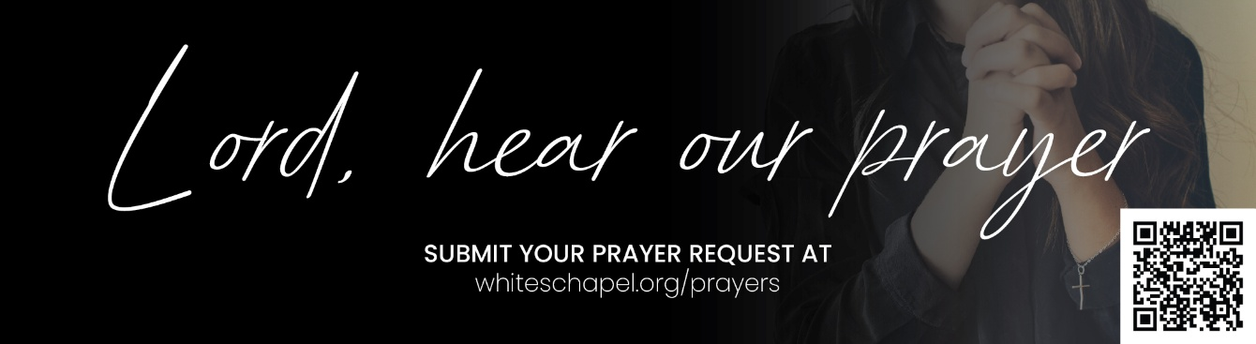
You may submit prayer requests at the following link or use this QR code: www.whiteschapel.org/prayers.html. Names will remain on this prayer list for two weeks, three weeks for deaths, unless otherwise notified.

Public Prayer List 09-14-2026

Daniel Adams, Angle Atlee, Sally Andrusin, Jimmy Arnold, Kenneth Arnold, Taylor Barham, Dudley Barnes, Jason Bolanz, Nancy Bowman, Ellen Bratton and Floyd McGlothin, Carol Burns, Joe Burns, Dennis Burt, Bryan Callahan, Kay Chapman-Coy, Bill Charters, Carolyn Cockerell, Jenna Comparin, Miles Cook, Bill and Jimmie Nell Cook, Claudia Ann Courtney, Terri Craddock, Leslie Craig, Jim Damon, Melodi Doran, Amy Duckworth, Richie Ellison, Linda Evans, Ralph Evans, Jeff Evans, Andy Evans, Andy Flansburg, Jeff and Leslie Giles, Jeremy and Jamie Goad, Cynthia Gonzalez, Thomas Grant, Arthur and Dianne Gravely, Sheena Hall, Buddy Hall, Patricia Hardman, Kay Hasseltine, Carolyn Hausler, Brian Heidebrecht, Patricia Hendricks, Jim Hoffman, Ronnie Holcombe, Alice Knowles-Holliday, Paul Holmes, Mary Howry, Dixie Hubbard, Jack Keen, Christopher Kender, Dolores Kopesec, Charles Kriska, JoAnn Lee, Michael Lee, Michael Lucas, Lori Eagleston Luedtke, Lucas Lunday, Cindy Marshall, Rustico T. Martinez, Tena McCall, Don McCall, Courtney McDougal, Sue McNutt, Stan and Patty Mersenski, Ashley Miller, Jeff Miller, Kevin Mitchell, Nelda Morrow-Winblood, Connie Muncy, Jeff Nadeau, Linda Nadeau, Joy Paprskar, Warren Parr, Azor Phelps Sr., Bill Preston, Dailen Ramirez, Brent Ratliff, Amber Reeves, William Rowntree and Family, Pamela Salvador, Gregg Short, Larry Slack, JJ Snook, Jamieson Stewart, Jim Stow, Luke Strain, Steve Swanston, Michelle Sweitzer, Jerry Tassa, Texas Grass Fires, Brad Veach, Rick Warner, Shannon Weimers, Nan Wenrich, Leslie Westerman, Weston Whalen, Megan and Eric Whitehead, Lindsey Wild, Carroll Willis, Vicki Winn, Melinda Witt, Bobby Wroten, Irma Zamora, Colin, Carter. Recent deaths: The Family of Dave Aistrup, The Family of Patricia Blasdel, The Family of Tori Burkett, The Family of Jim Chambers, The Family of Brenda Clark, The Family of Shirley Clay, The Family of Heinrich Downes, The Family of Ashley Gardiner, The Family of Patricia Garrett, The Family of Beverly McDonald, The Family of Joe McNamara, The Family of Bill Miller, The Family of Matthew Mitchell, The Family of Helen Post, The Family of Spencer Strong, The Family of Jack Wiggers, The Family of Judy Wildhaber.

