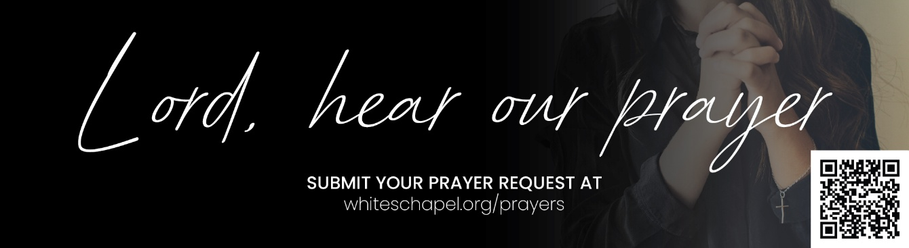
You may submit prayer requests at the following link or use this QR code: www.whiteschapel.org/prayers.html. Names will remain on this prayer list for two weeks, three weeks for deaths, unless otherwise notified.

Public Prayer List 09-28-2026

Patti Ackley, Jimmy Adamcik, Daniel Adams, Malta Akins, Jackie Allen, Sally Andrusin, Blake Avers, Eric Avery, David Ball, Peyton Balough, Taylor Barham, Dudley Barnes, Mike Betts, Sue Bossow, Nancy Bowman, Ellen Bratton and Floyd McGlothin, Andrew Bregger, Judy Brookman, Kevin Buchanan, Joe Burns, Bryan Callahan, Dan Carlyle, Carolyn Cockerell, Bill and Jimmie Nell Cook, Sallie Corbitt, Claudia Ann Courtney, Leslie Craig, Jim Damon, Amy Duckworth, Jeff Evans, Linda Evans, Ralph Evans, Andy Evans, Andy Flansburg, Ellis Gillis, Arthur and Dianne Gravely, Sheena Hall, Buddy Hall, Saira Hayse, Patricia Hendricks, Jim Hoffman, Dixie Hubbard, Justin Itz, Jan Jackson, James Kelley, Paula King, Marthajane King, Dolores Kopesec, Charles Kriska, Connie Lamb, Michael Lee, Louis Lowrence, Michael Lucas, Lori Eagleston Luedtke, Lucas Lunday, Derek Mann, Cindy Marshall, Courtney McDougal, Sue McNutt, Stan and Patty Mersenski, Jeff Miller, Dwight Monroe, Nelda Morrow-Winblood, Jeff Nadeau, Christopher Owen, Rick Peterson, Azor Phelps Sr., Dana Pierce, Jim Posey, Bill Preston, Dailen Ramirez, Brent Ratliff, Andrea Robinson, William Rowntree and Family, Wanda Sewell, Gregg Short, Matthew Sinopoli, Larry Slack, Darrell Smith, JJ Snook, Jamieson Stewart, Luke Strain, Steve Swanston, Karen Thompson, George Townson, Jennifer Vasek, Tom Walker, Rick Warner, Claire Webb, Shannon Weimers, Nan Wenrich, Carly West, Leslie Westerman, Carroll Willis, Vicki Winn, Melinda Witt, Colin, Lilah, Karen. Recent deaths: The Family of Jimmy Arnold, The Family of Patricia Blasdel, The Family of Danny Brown, The Family of Tori Burkett, The Family of Shirley Clay, The Family of Terri Craddock, The Dominguez Family, The Family of Heinrich Downes Jr., The Family of Patricia Garrett, The Garrett Family, The Family of Jared Hazleton, The Family of Bill Hudson, The Family of Jerry Kight, The Family of Bill Miller, The Family of Ivy Odom, The Family of Audrey Sorgel, The Family of Jack Wiggers, The Family of Judy Wildhaber.

